

CSE 303 MINI PROJECT REPORT
Submitted By
Name: Najmul Haque Majumder
ID:2022-2-60-059
Name: KM Iftekhar Uddin
ID:2022-2-60-034
Name: Fariha Khandakar Moon
ID:2022-2-60- 047
Submitted To
DR. Mohammad Manzurul Islam

Introduction:
We have a dataset that is mainly Concrete Compressive Strength prediction. We have a characteristics of multivariate Dataset . We have the number of record is 1030. Number of features is 8 . We have no missing value here . Our model is basically regression based because we don’t have any ordinal or binary features. In our model we have continuous and integer value here. We have chosen the dataset Because this dataset type is regression type . which is best for linear regression . our main goal is to build a good machine learning model which can
predict the value of concrete compressive strength of any data we give to this model .

Dataset Description: we have integer and continuous value in our dataset . we don’t have any binary or categorical value in our dataset. We have 1031 row and 9 columns in our dataset. Our target variable is Concrete compressive strength . In our dataset we have no missing values or zero values. Our data is mainly numerical we have no categorical values in our dataset. In our features we have cement amount , Blast Furnace Slag , Fly Ash , Water , Superplasticizer ,Coarse Aggregate , Fine Aggregate , Age. Blust Furnace slag is a byproduct produced during the manufacturing of iron in a blast furnace. It is use in cement and concrete as a substitute of Portland cement. Fly ash this is also a byproduct of cement . Water is also needed for the concrete compressive strength. We have also Coarse aggregate , Fine aggregate which is also a necessary product of concrete compressive strength. Our target is find out the Concrete compressive strength prediction . All of our features are continuous except two which are integer Blast furnace slag , age .
Data Preprocessing: Our dataset is mainly continuous and integer value based . we don’t have any categorical values that was a advantage for our dataset. So we don’t have to convert anything . we have also no missing values in our dataset So we don’t need to replace value with mean , mode , median. We also don’t have to mapping.
Exploratory Data Analysis (EDA):
Heatmap:
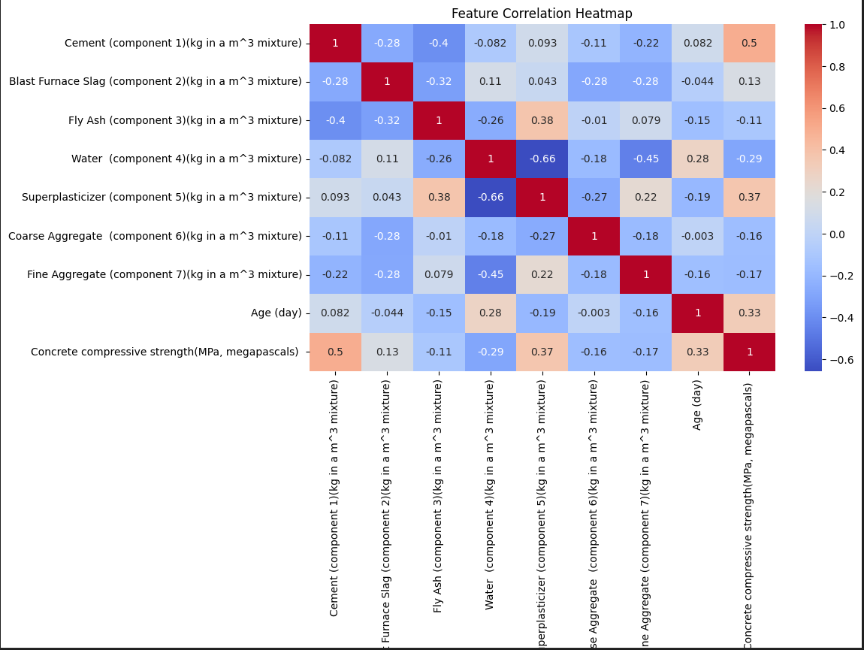

Here in our heatmap Cement correlation is +0.5. More cement can increase compressive strength. Superplasticizer correlation is +0.37 Superplasticizer can improves strength by reducing water content. Age day correlation is +0.33. we have also find out negative correlations which one is water -0.29. we have also flyash, Coarse Aggregate , Fine Aggregate -0.1 to -0.17. we have a weak correlation value that is Blast Furnace slag +0.13. we have some highly correlated feature pairs that is cement vs concrete compressive strength +0.5. Strong negative correlation water vs superplasticizer . Fine aggregate vs itself +1.0.
Bar chat: 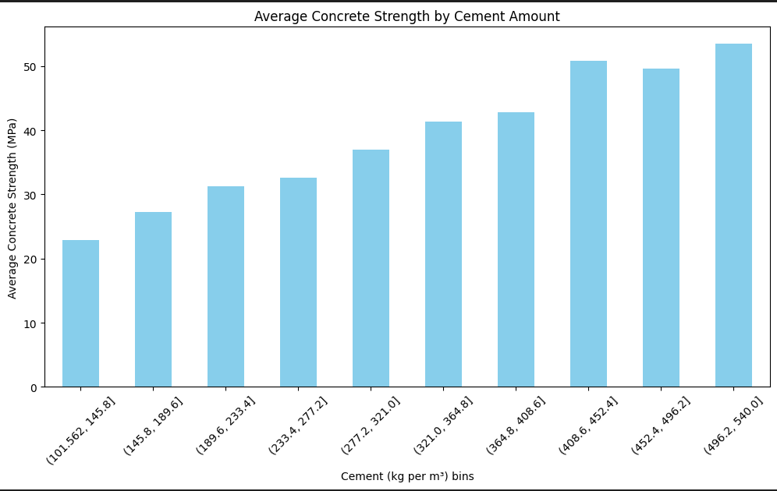
Positive relationship:
1.As cement content increases, the average concrete strength also increases.
2.Low cement is equal to low strength
The lowest bin we have is (101.562-145.8) has the average lowest strength of 23Mpa
3.High cement = High Strength
The highest bin we have is (496.2-540.0) has the highest average strength of 53Mpa
4.There is slight pletu in 452-496 before rising again.
Pie Chart:
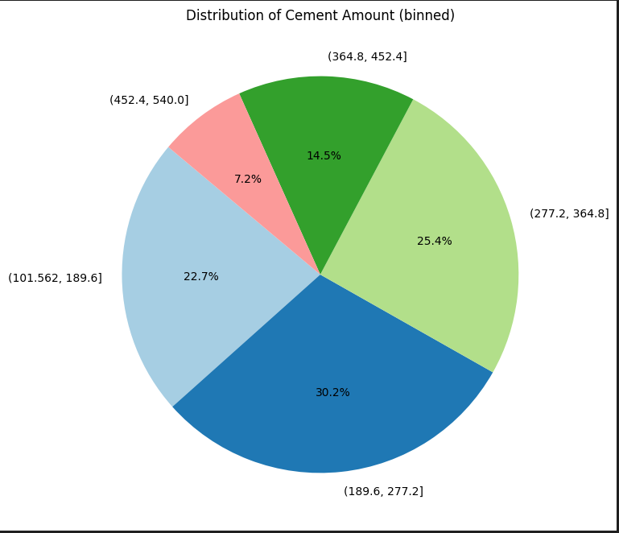
- Most common cement amount range is (189.6-277.2) 30.2%
- Moderately common rages are (101.562-189.6) 22.7% and (277.2-364.8) 25.4%
- Less common cement amount range is (452.4-540) 7.2% and (364.8-452.4) 14.5%
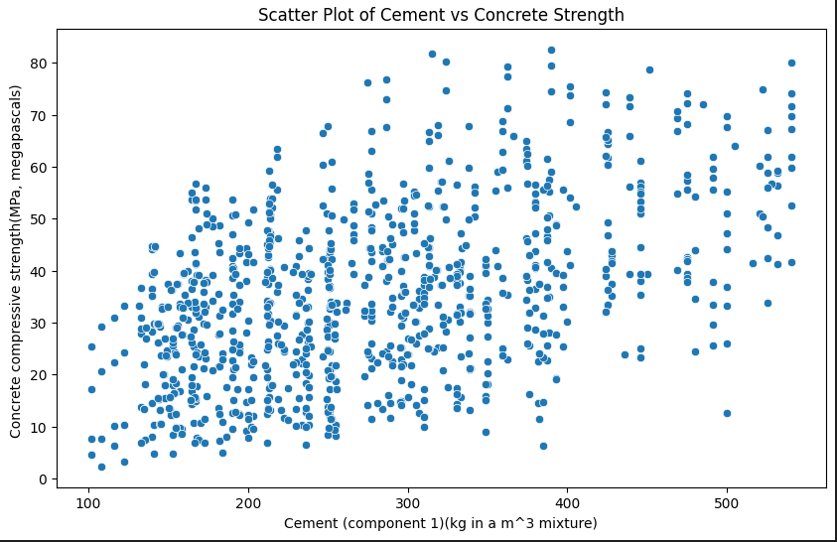

Scatter plot:
There is a positive clear trend we can see as the amount of cement increases the strength of concrete compressive strength increases. This point out that cement is significant factor in the concrete compressive strength. Data spread at lower cement area amount (100-200 kgm³) the concrete strength is generally low. As cement content rises (300-500+ kgm³)the strength tends to higher . At very high cement amounts > (400 kgm3)the strength does not increase linearly.

Machine Learning Models: we have use linear regression because our dataset is continuous and integer value based. we have calculate the MSE (95.98) . We have also calculated (RMSE) 9.80 . R2 Value is 0.63. we didn’t have confusion matrix because our model is based on linear regression .

Conclusion: we have got the R squared value 0.68 where we can predict the 68% data rightly . we have apply also SVR where we got 0.82 R squared value that is better than the previous . we can improve our model by create new features , transform non-linear relationships , remove irreverent or highly correlated features to reduce noise. We can also use some techniques like Hyperparameter Tuning , Cross validation , Outlier Detection use boxplots or Z scores to detect and handle outliers .

